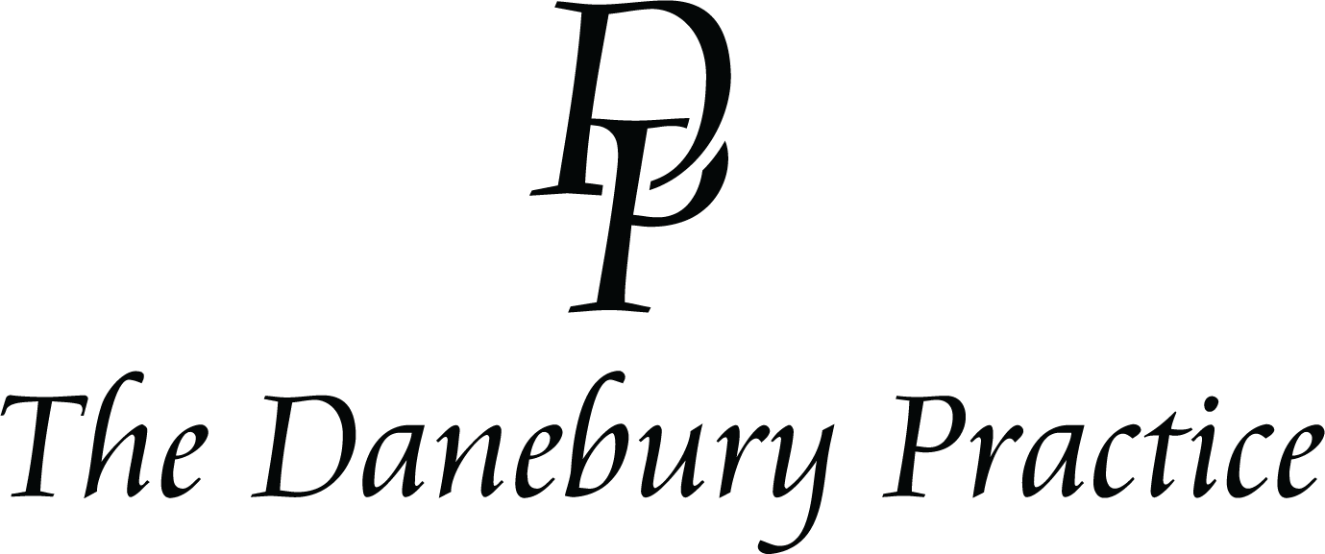

Monthly Membership Skin Treatments – Terms & Conditions

1. About the Membership
Our Monthly Skin Treatment Membership allows clients to enjoy selected aesthetic and skin treatments for a fixed monthly fee. Membership benefits, included treatments, and pricing are outlined at the time of joining and may vary depending on the membership tier selected.
Membership is personal to the named client and cannot be transferred to another individual.

2. Eligibility & Medical Assessment
Membership is available to clients aged 18 years and over.
All treatments are subject to a consultation and skin or medical suitability assessment. We reserve the right to refuse or postpone treatment where it is not clinically appropriate or safe.
Clients must provide accurate and complete medical information. Failure to do so may result in treatment being declined without refund.

3. Included Treatments
Only treatments specifically listed as part of your Membership are included.
Treatments must be used within the monthly membership period and cannot be carried over unless explicitly stated. Unused treatments are forfeited at the end of each month.
Membership treatments cannot be exchanged for cash or substituted for alternative treatments.

4. Payments
Membership fees are payable by monthly direct debit or recurring card payment.
The first payment is taken at the time of joining, with subsequent payments taken monthly.
Memberships are subject to a minimum commitment period. Failure to make payment may result in suspension or cancellation of benefits.

5. Cancellation & Termination
After the minimum commitment period, membership may be cancelled by providing 30 days’ written notice.
No refunds are given for partial months or unused treatments.
We reserve the right to terminate membership immediately for missed payments, repeated missed appointments, inappropriate behaviour, or where treatment is deemed clinically unsafe.

6. Appointments & Cancellations
Appointments are subject to availability and must be booked in advance.
At least 48 hours’ notice is required to cancel or reschedule appointments. Late cancellations or non-attendance may result in forfeiture of that month’s treatment.

7. Treatment Results
Individual results vary and no guarantee of outcome can be given.
Multiple sessions may be required. We are not responsible for dissatisfaction arising from unrealistic expectations or failure to follow aftercare advice.

8. Changes to Membership
We reserve the right to amend membership pricing, included treatments, or these Terms & Conditions with reasonable notice.
Changes will not affect an existing minimum commitment period.

9. Pausing Membership
Membership may be paused only in exceptional circumstances, such as medical reasons, and at our discretion. Supporting evidence may be requested.

10. Refunds
Membership fees are non-refundable, except where required by law.

11. Liability
All treatments are carried out by trained and appropriately qualified practitioners.
We are not responsible for adverse outcomes where aftercare advice has not been followed.
Nothing in these Terms limits liability for death or personal injury caused by negligence.

12. Data Protection
We process personal and medical data in accordance with UK GDPR and our Privacy Policy. All information is stored securely and treated confidentially.

13. Governing Law
These Terms & Conditions are governed by the laws of England and Wales.

14. Acceptance of Terms
By joining our Monthly Skin Treatment Membership, you confirm that you have read, understood, and agreed to these Terms & Conditions.

January 2026

